1. Insert New Feedback

Input: Adding feedback for a customer and loan, capturing sentiments and details about the loan process.

Output Screen:

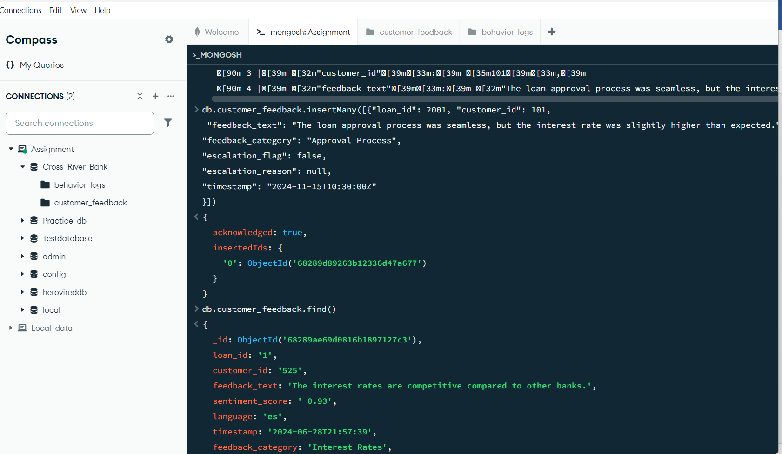

1. Update Escalation Flags.

Input: Update escalation flags in feedback to include specific reasons for unresolved customer complaints.

Output Screen:

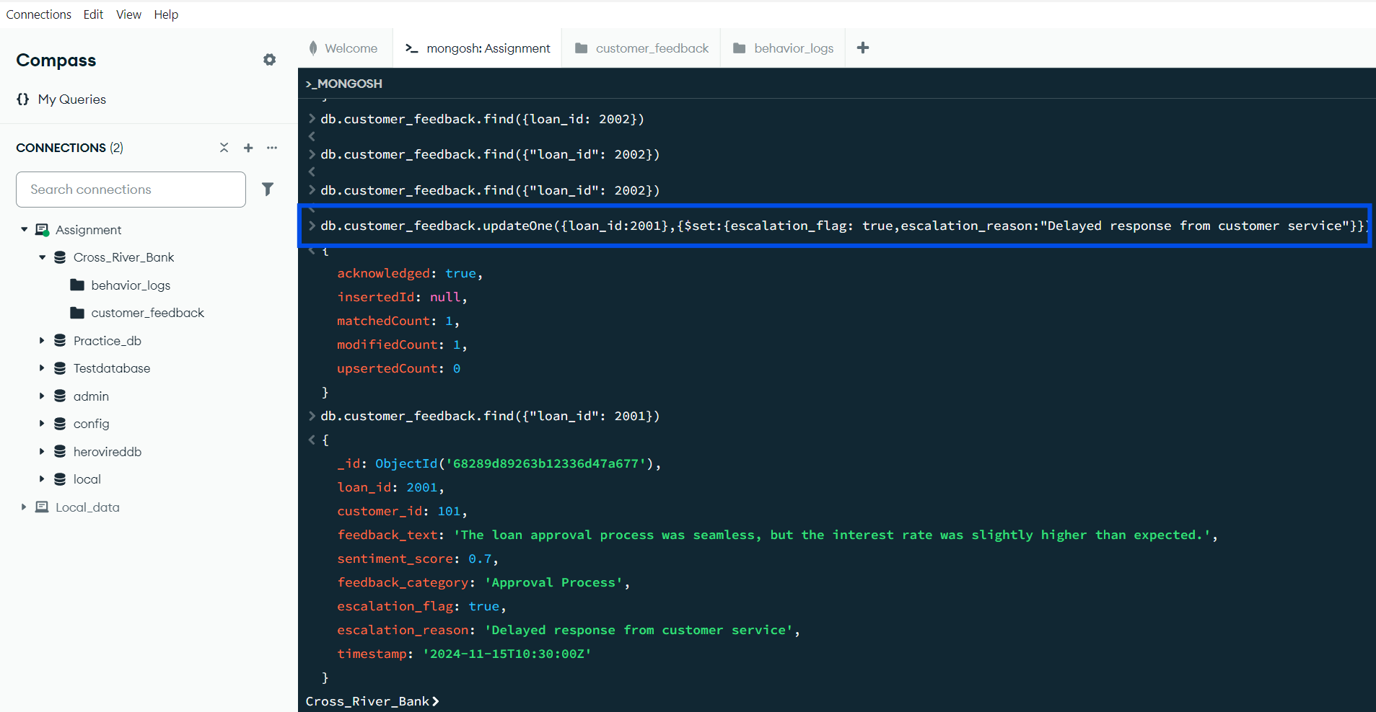

1. Retrieve Positive Feedback.

Input: Retrieve feedback entries with sentiment scores greater than 0.5.

Output Screen:

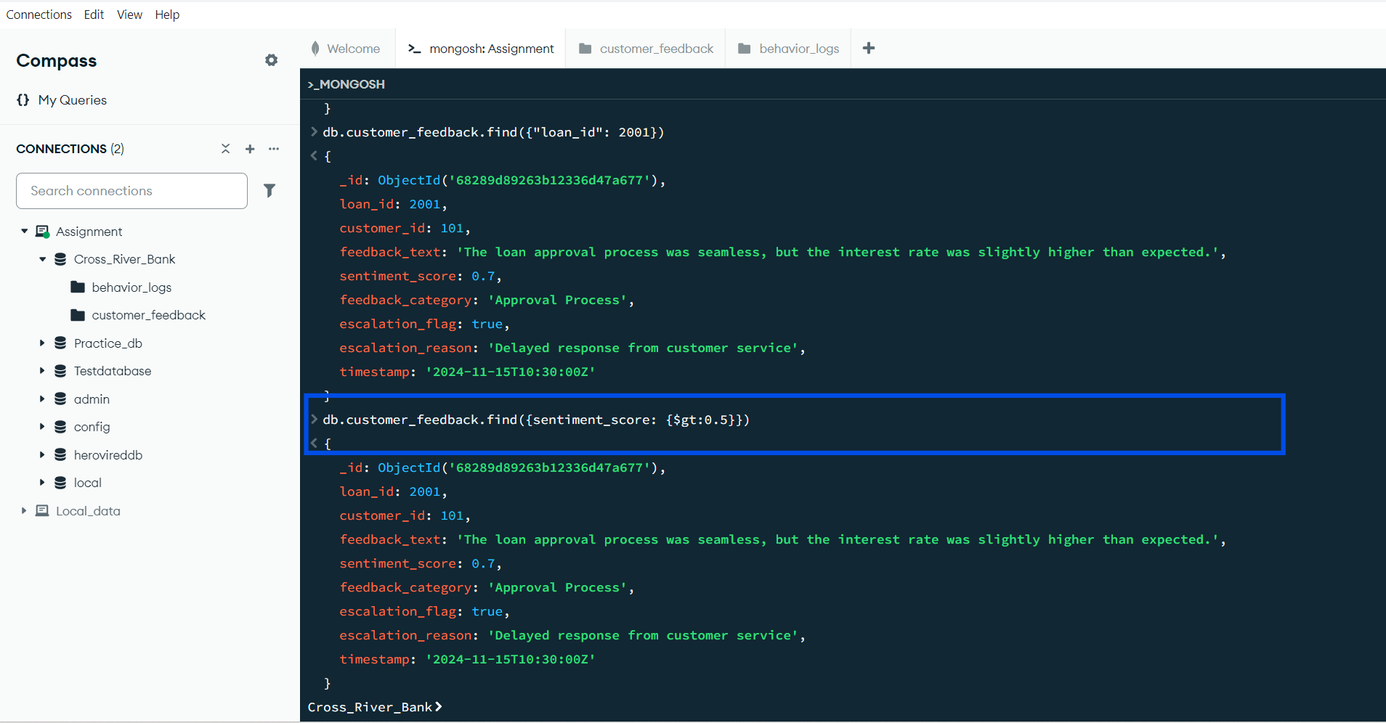

1. Fetch Logs for 'Missed Payment' Actions.

Input: Retrieve behavior logs where the action is "Missed Payment."

Output Screen:

